# Experiment-5

**Name:** SAHIL KASHYAP **UID:** 22BET10302

**Branch:** BE-IT **Section/Group:** 22BET_IOT-702/A

**Semester:** 6th **Date of Performance:**21/02/25

**Subject Name:** AP LAB-II **Subject Code:** 22ITP-351

**Problem-1**

**1.Aim:**

You are given two integer arrays nums1 and nums2, sorted in non-decreasing order, and two integers m and n, representing the number of elements in nums1 and nums2 respectively.

**2.Objective:**

* Merge two sorted integer arrays, nums1 and nums2, into a single sorted array.
* Store the merged result in nums1, which has sufficient space (size m + n).
* Maintain non-decreasing order in the merged array.
* Perform the merge operation in-place without using extra space.
* Efficiently handle elements from both arrays while merging.

## 3.Code:

class Solution {

public:

    void merge(vector<int>& nums1, int m, vector<int>& nums2, int n) {

        int i=m-1 , j=n-1 ;

        while(i>=0 && j>=0 ){

            if(nums1[i]>=nums2[j]){

                nums1[i+j+1]=nums1[i] ;

                i-- ;

                }else{

                    nums1[i+j+1]=nums2[j];

                    j-- ;

                }

        }

        while(j>=0){

                    nums1[j]=nums2[j];

                    j-- ;

                }

    }

};

## 4.Output:

**Problem-2**

**1.Aim:**

Given an integer array nums and an integer k, return *the* k *most frequent elements*. You may return the answer in any order.

**2.Objective:**

## Identify the k most frequent elements in the given integer array nums.

## Return these k elements in any order.

## Efficiently determine element frequencies and extract the top k frequent elements.

## Optimize for performance, ideally using a heap or other efficient data structures.

## 3.Code:

## class Solution {

## public:

## vector<int> topKFrequent(vector<int>& nums, int k) {

## unordered_map<int, int> ump;

## for(int i: nums){

## ump[i]++;

## }

## priority_queue<pair<int, int>>pq;

## for(auto i: ump){

## pq.push({i.second,i.first});

## }

## vector<int> res;

## while(k--){

## auto [elem, count] = pq.top();

## res.push_back(count);

## pq.pop();

## }

## return res;

## }

## };

## 4.Output:

## Fig.2:Top K frequent Elements

# Problem-3

# 1.Aim:

A peak element is an element that is strictly greater than its neighbors.Given a 0-indexed integer array nums, find a peak element, and return its index. If the array contains multiple peaks, return the index to any of the peaks.

**2.Objective:**

## Identify a peak element in the given 0-indexed integer array nums.

## A peak element is strictly greater than its neighbors.

## If multiple peaks exist, return the index of any one of them.

## Ensure an efficient approach, ideally using binary search instead of a linear scan.

## 3.Code:

## class Solution {

## public:

## int findPeakElement(vector<int>& nums) {

## int n= nums.size();

## int s=0;

## int e=n-1;

## while(s<e){

## int m = s + (e-s) / 2;

## 

## if(nums[m] > nums[m+1]){

## e = m;

## }

## else{

## s = m +1;

## }

## }

## return s;

## 

## }

## };

## 4.Output:

## 

**Fig.3:Find Peak Element**

# Problem-4

**1.Aim**: Given two sorted arrays nums1 and nums2 of size m and n respectively, return the median of the two sorted arrays.

**2.Objective:**

## To find the median of two sorted array

## The overall run time complexity should be O(log (m+n)).

## 3.Code:

## class Solution {

## public:

## double findMedianSortedArrays(vector<int> &nums1, vector<int> &nums2) {

## int n1 = nums1.size(), n2 = nums2.size();

## 

## // Ensure nums1 is the smaller array for simplicity

## if (n1 > n2)

## return findMedianSortedArrays(nums2, nums1);

## 

## int n = n1 + n2;

## int left = (n1 + n2 + 1) / 2; // Calculate the left partition size

## int low = 0, high = n1;

## 

## while (low <= high) {

## int mid1 = (low + high) >> 1; // Calculate mid index for nums1

## int mid2 = left - mid1; // Calculate mid index for nums2

## 

## int l1 = INT_MIN, l2 = INT_MIN, r1 = INT_MAX, r2 = INT_MAX;

## 

## // Determine values of l1, l2, r1, and r2

## if (mid1 < n1)

## r1 = nums1[mid1];

## if (mid2 < n2)

## r2 = nums2[mid2];

## if (mid1 - 1 >= 0)

## l1 = nums1[mid1 - 1];

## if (mid2 - 1 >= 0)

## l2 = nums2[mid2 - 1];

## 

## if (l1 <= r2 && l2 <= r1) {

## // The partition is correct, we found the median

## if (n % 2 == 1)

## return max(l1, l2);

## else

## return ((double)(max(l1, l2) + min(r1, r2))) / 2.0;

## }

## else if (l1 > r2) {

## // Move towards the left side of nums1

## high = mid1 - 1;

## }

## else {

## // Move towards the right side of nums1

## low = mid1 + 1;

## }

## }

## 

## return 0; // If the code reaches here, the input arrays were not sorted.

## }

## };

## 4.Output:

## 

**Fig.4:Median Of Two Sorted Array**

# Problem-5

**1.Aim:** Given an n x n matrix where each of the rows and columns is sorted in ascending order, return the kth smallest element in the matrix.

**2.Objective:**

## kth smallest element in the sorted order, not the kth distinct element.

## 3.Code:

## class Solution {

## public:

## int kthSmallest(vector<vector<int>>& matrix, int z) {

## int n = matrix.size(), m = matrix[0].size();

## int a[n*m], k=0;

## for(int i=0; i<n; i++){

## for(int j=0; j<m; j++){

## a[k] = matrix[i][j];

## k++;

## }

## }

## sort(a, a+(n*m));

## return a[z-1];

## }

## };

## 4.Output:

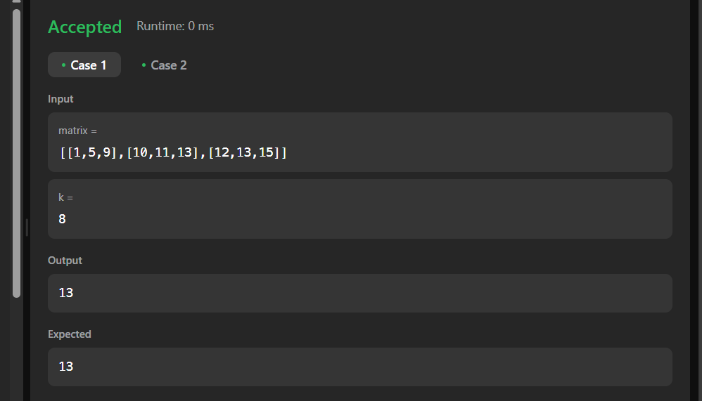

**Fig.5:kth smallest element**